EXP-9

**Create an Application to Send and Receive Multimedia Messages (Text, Image, Audio)**

# Aim:

To develop a basic chat-like application that allows:

* Sending and receiving text, images, and audio
* Using local file selection and simulated messaging UI

# Procedure:

1. Create a GUI using tkinter.
2. Enable sending:
   * Text via entry box
   * Images via file dialog and display
   * Audio via file selection and play
3. Use a scrollable chat window to simulate message exchange.
4. Optionally add threading for media playback.

# Code:

import tkinter as tk

from tkinter import filedialog, scrolledtext from PIL import Image, ImageTk

from playsound import playsound import threading

# Send text message def send_text():

msg = text_entry.get()

if msg:

chat_box.insert(tk.END, f"You: {msg}\n") chat_box.yview(tk.END) text_entry.delete(0, tk.END)

# Send image message def send_image():

path = filedialog.askopenfilename(filetypes=[("Image Files", "*.jpg *.png *.jpeg")]) if path:

chat_box.insert(tk.END, f"You sent an image: {path}\n")

# Open and resize image img = Image.open(path) img.thumbnail((100, 100))

img_tk = ImageTk.PhotoImage(img)

# Display image in chat

image_label = tk.Label(chat_frame, image=img_tk) image_label.image = img_tk # keep reference image_label.pack()

chat_box.yview(tk.END)

# Send audio message def send_audio():

path = filedialog.askopenfilename(filetypes=[("Audio Files", "*.mp3 *.wav")]) if path:

chat_box.insert(tk.END, f"You sent an audio message: {path}\n")

chat_box.yview(tk.END) threading.Thread(target=lambda: playsound(path)).start()

# GUI Setup window = tk.Tk()

window.title("Multimedia Messaging App") window.geometry("450x500")

# Chat area

chat_frame = tk.Frame(window)

chat_box = scrolledtext.ScrolledText(chat_frame, wrap=tk.WORD, width=50, height=20) chat_box.pack()

chat_frame.pack(pady=10)

# Text entry and buttons

text_entry = tk.Entry(window, width=30) text_entry.pack(side=tk.LEFT, padx=5)

btn_text = tk.Button(window, text="Send Text", command=send_text) btn_image = tk.Button(window, text="Send Image", command=send_image) btn_audio = tk.Button(window, text="Send Audio", command=send_audio)

btn_text.pack(side=tk.LEFT, padx=2) btn_image.pack(side=tk.LEFT, padx=2) btn_audio.pack(side=tk.LEFT, padx=2)

window.mainloop()

# Output:

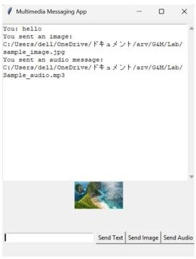

**Result:**

A multimedia messaging interface was successfully created with options to send text, image, and audio content. The application simulated messaging behavior in a local environment.